Part Number: PTR13-53093 (RF Shock)

PTR13-53094 (LF Shock)

PTR13-53140 (Rr Shocks)

Kit Contents (Each Front Shock)
Item # | Quantity Reqd. | Description
1 | 2 | RF/LF Shock Absorber
2 | 2 | Hardware Bag
Kit Contents (Each Rear Shock)
Item # | Quantity Reqd. | Description
1 | 2 | Rear Shock Absorber
2 | 2 | M12 x 1.25 Lock Nut
3 | 4 | Collar (spacer)
Hardware Bag Contents (Each Front Shock)
Item # | Quantity Reqd. | Description
1 | 2 | Spring Seat
2 | 2 | Locking Shock Nut
3 | 4 | Shock Collet (spacer)
Additional Items Required For Installation
Item # | Quantity Reqd. | Description
1
Conflicts
AWD, Convertible and AVS-equipped models
General Applicability
RWD IS models (Hardtop only)
Recommended Sequence of Application
Item # | Accessory
1 | F-Sport Shocks should be installed at the same time as F-Sport Springs
2 | F-Sport Shocks should be installed before F-Sport rear brakes
*Mandatory
Recommended Tools
Personal & Vehicle Protection | Notes
Fender Covers
Safety Glasses
Special Tools | Notes
Spring Compressor
Transmission Jack | To work high under a lift
Floor Jack | To work low with a vehicle lift or on the ground
2” x 4” Wood Block | ~4”long if using floor jacks
Installation Tools | Notes
Torque Wrench | 3/8” & ½” drive
Ratchet | 3/8” & ½” drive
Wrenches | 14, 19, 17, 24mm
Sockets | 10, 14, 17, 19mm
Hexagon Socket | 6 mm
Screwdriver | Small & long flat-head
Nylon Pry Tool
Awl
Special Chemicals | Notes
Vehicle Service Parts (may be required for reassembly)
Item # | Quantity Reqd. | Description
1 | 90467-12069 | Clip for luggage compartment trim cover (2)
Legend
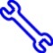
STOP: Damage to the vehicle may occur. Do not proceed until process has been complied with.
OPERATOR SAFETY: Use caution to avoid risk of injury.
CAUTION: A process that must be carefully observed in order to reduce the risk of damage to the accessory/vehicle and to ensure a quality installation.
TOOLS & EQUIPMENT: Used in Figures calls out the specific tools and equipment recommended for this process.
REVISION MARK: This mark highlights a change in installation with respect to previous issue.
SAFETY TORQUE: This mark indicates that torque is related to safety.

Care must be taken when installing this accessory to ensure damage does not occur to the vehicle. The installation of this accessory should follow approved guidelines to ensure a quality installation.

These guidelines can be found in the "Accessory Installation Practices" document.

This document covers such items as:-
- Vehicle Protection (use of covers and blankets, cleaning chemicals, etc.).
- Safety (eye protection, rechecking torque procedure, etc.).
- Vehicle Disassembly/Reassembly (panel removal, part storage, etc.).
- Electrical Component Disassembly/Reassembly (battery disconnection, connector removal, etc.).

Please see your Lexus dealer for a copy of this document.

Remove the Front Shock/Spring Assemblies.
  - Remove the front wheels.
CAUTION: Do not use an impact wrench on wheel locks (if equipped).
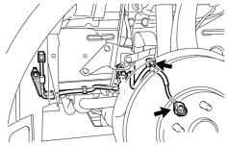
  - Detach the speed sensor wire from the shock absorber assembly and disconnect it from the speed sensor (Fig. 1-1).
10mm socket & ratchet
Fig. 1-1

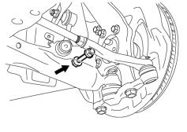
  - Remove the nut and bolt holding the lower end of the shock absorber (Fig. 1-2).
19mm socket & wrench and ratchet
Fig. 1-2

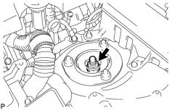
  - Loosen the front shock absorber lock nut (Fig. 1-3).
17mm socket & ratchet
Fig. 1-3
NOTE: Do not remove the lock nut.

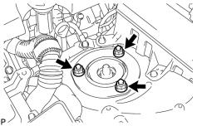
  - Remove the 3 nuts on the upper side of the front suspension support (Fig. 1-4).
14mm socket & ratchet
Fig. 1-4
NOTE: The lower arm bushing preload will not allow the shock assembly to fall.

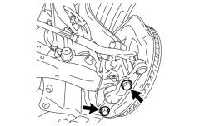
  - Remove the 2 bolts from the front lower ball joint (Fig. 1-5).
19mm socket & ratchet
Fig. 1-5
  - Remove the shock absorber/spring assembly from the vehicle.
  - Repeat Step 1 on the other side of the vehicle.

Replace the Shock Absorbers.
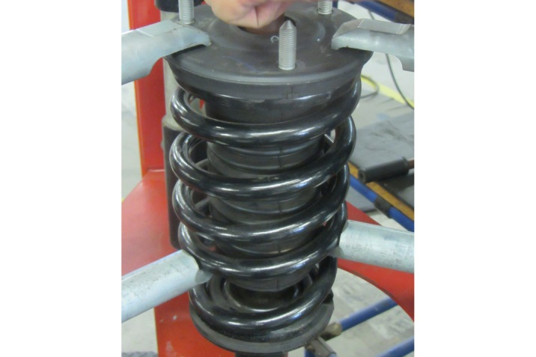
  - Compress the spring enough to remove tension from the upper spring support (Fig. 2-1).
Spring compressor
Fig. 2-1

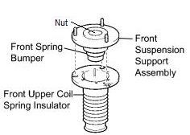
  - Remove the lock nut (Fig. 2-2). It will not be reused.
17mm socket & ratchet
Fig. 2-2
  - Remove the front suspension support assembly with the front upper coil spring insulator (Fig. 2-2). Retain them for reinstallation.
  - Remove the coil spring.
  - Place a provided spring seat over the new shock absorber assembly.
NOTE: A groove machined into the spring seat rests on the snap ring fitted to the body of the shock.
  - Transfer the lower spring insulator from the factory shock absorber to the new spring seat.
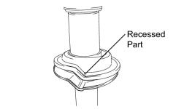
  - Confirm the lower spring insulator is indexed properly and free of debris (Fig. 2-3).
Fig. 2-3
  - Reinstall the factory spring bumper onto the front suspension support assembly.
  - Compress a front spring and place it over the shock absorber assembly.

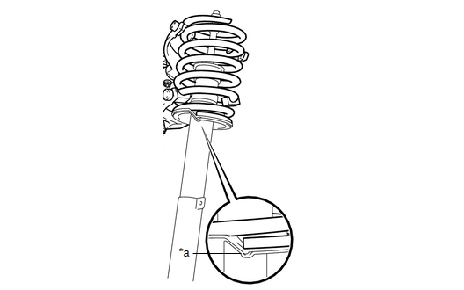
  - Confirm that the end of the spring sits in the stepped portion (*a) of the lower spring seat (Fig. 2-4).
Fig. 2-4

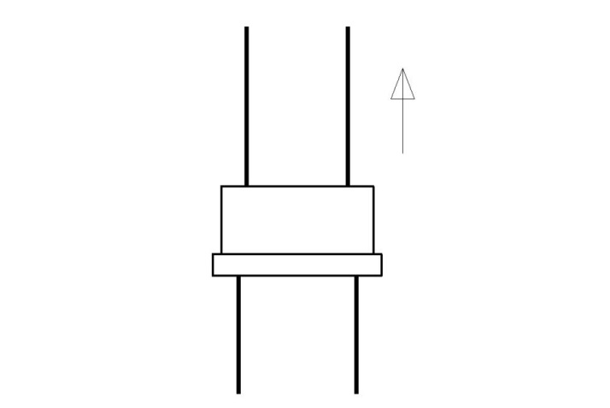
  - Place a supplied collet/spacer over the piston shaft (Fig. 2-5).
Fig. 2-5
NOTE: If the collet supplied with the shock absorber has no lip, the direction of the collet does not matter.

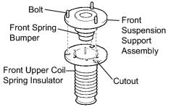
  - Align the bolt heads of the front suspension support assembly with the cutouts of the front upper coil spring insulator (Fig. 2-6).
Fig. 2-6
  - Install the front upper coil spring insulator on the front suspension support assembly (Fig. 2-6).

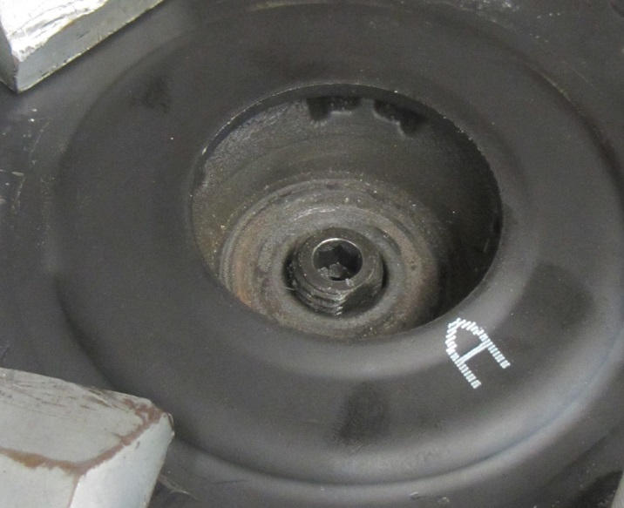
  - Match the shape of the piston shaft end to the hole in the front suspension support assembly to install the front shock absorber (Fig. 2-7).
Fig. 2-7
Flats
NOTE: Do not remove the collar from the shock absorber piston shaft.

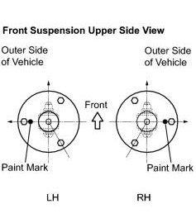
  - Align the front suspension support assembly to the position shown (Fig. 2-8).
17mm socket & ratchet
Fig. 2-8
  - Temporarily tighten a supplied lock nut to the front shock absorber.

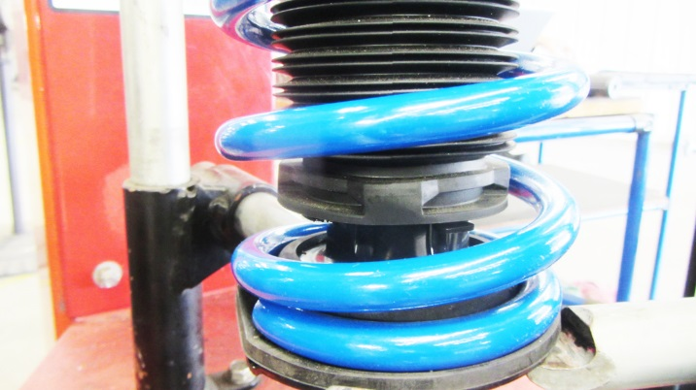
  - MY 2015+: Clip the dust boot into the 4 tabs (Fig. 2-9).
Fig. 2-9
Tab
4X

Install the Front Shock/Spring Assemblies.
  - Replace the front shock absorber assembly into the vehicle and tighten the 3 nuts on the suspension support (engine bay) side (Fig. 3-1).
14mm socket & torque wrench
Fig. 3-1
Torque: 67 N·m (683 kgf·cm, 49 ft·lbf)

  - Install the front shock absorber lower side on the front lower suspension arm and insert the bolt from the rear of the vehicle (Fig. 3-2).
19mm socket & wrench and ratchet
Fig. 3-2
  - Temporarily tighten the nut while holding the bolt.
NOTE: The nut will be fully tightened after settling the suspension.

  - Torque the new shock absorber assembly lock nut (Fig. 3-3).
17mm socket & torque wrench
Fig. 3-3
Torque: 28 N·m (286 kgf·cm, 21 ft·lbf)

  - Replace the 2 bolts into the front lower ball joint (Fig. 3-4).
17mm socket & torque wrench
Fig. 3-4
NOTE: Be sure to hand start the bolts before using tools.
Torque: 120 N·m (1,220 kgf·cm, 89 ft·lbf)

  - Install the front speed sensor to the front shock absorber and reconnect it (Fig. 3-5).
10mm socket & torque wrench
Fig. 3-5
Torque: 13.5 N·m (138 kgf·cm, 10 ft·lbf)

  - Torque the lower shock absorber bolt (Fig. 3-6). Compress the lower suspension arm to support the weight of the vehicle.
19mm socket & wrench and torque wrench
Fig. 3-6
CAUTION: The nut has a locking feature. Tighten the bolt and nut by turning the BOLT while the nut is held in place.
Torque: 180 N·m (1,835 kgf·cm, 133 ft·lbf)
  - Repeat Step 3 on the other side of the vehicle.
  - Install the front wheel/tire assemblies onto the vehicle. Hand start the lug nuts.

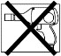
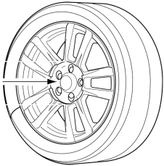
  - Use a torque wrench to tighten the lug nuts in sequence 1 through 5 to 103N∙m (76 ft-lbf) (Fig. 3-7).
2x

Fig. 3-7
Torque 2 Cycles
(All Lugs/Locks)
Torque: 103N∙m (76 ft-lbf)
  - Re-torque all of the lug nuts in same the 1-5 sequence (Fig. 3-7).
Torque: 103N∙m (76 ft-lbf)
CAUTION: DO NOT USE AN IMPACT WRENCH TO INSTALL OR REMOVE WHEEL LOCKS.

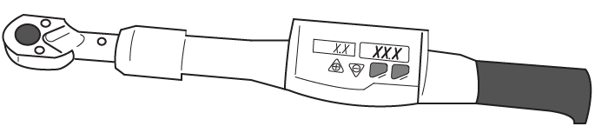
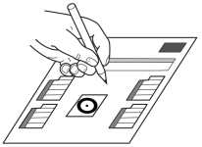
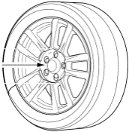
  - With the vehicle still on the lift, use a digital torque wrench to measure the torque of each lug nut/lock and record it on the Torque Audit Sheet (Fig. 3-8). (PPO installation only. Does not apply to DIO installation.)

Fig. 3-8
Measure Torque and Document
(All Lugs/Locks)

Remove the Rear Shock Absorbers.
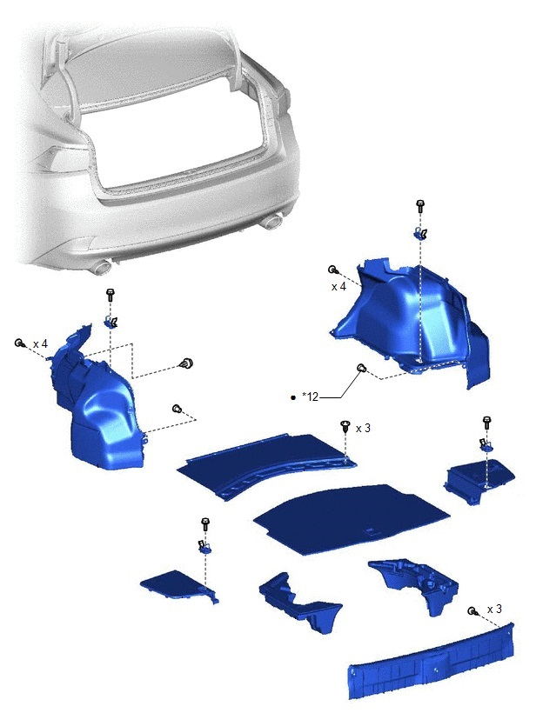
  - Remove the spare tire cover (Fig. 4-1).
10mm socket, ratchet & nylon pry tool
Fig. 4-1
  - Remove the rope hook assemblies (Fig. 4-1).
  - Remove the deck side trim boxes (Fig. 4-1).
  - Remove the rear luggage compartment trim cover (Fig. 4-1).
HINT: Once the rear trim cover is removed, place a fender cover or blanket over the rear bumper skin for protection.
  - Remove the front luggage compartment trim cover (Fig. 4-1).

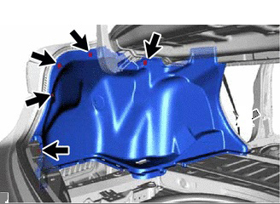
  - Remove the indicated 5 clips from the side trim cover (Fig. 4-2).
Small screwdriver or pick
Fig. 4-2
HINT: The rear most clip will require a small screwdriver or pick to release it from the panel.
  - Swing the back edge of the side cover in towards the center of the trunk to allow access to the top of the shock absorber.
CAUTION: Take care not to crease the side cover.
  - Raise the vehicle and remove the rear wheels.
CAUTION: Do not use an impact wrench on wheel locks (if equipped).

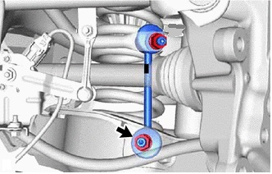
  - Remove the nut and disconnect the lower end of the sway bar links from the lower control arms on both sides of the vehicle (Fig. 4-3). Retain the nuts for reinstallation.
17mm socket, ratchet & 6mm hex wrench
Fig. 4-3
HINT: If the ball joint turns together with the nut, use a 6mm hexagon socket wrench to hold the stud bolt.
  - Separate the rear shock absorber from the lower control arm.
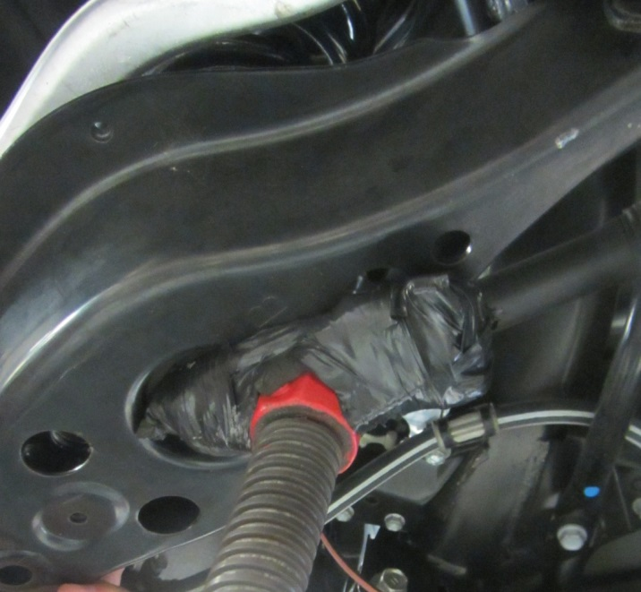
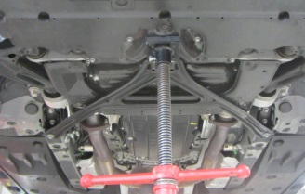
    - Compress the lower control arm by locating a jack below the spring area of the lower control arm (Fig. 4-4).
Fig. 4-4
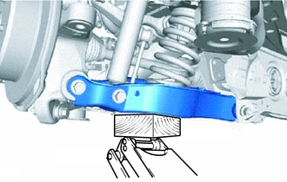
NOTE: A transmission jack can be used if working high or a floor jack can be used if working low to the ground (Fig. 4-5). Support the front cross member if a transmission jack is used (Fig. 4-4 inset).
Fig. 4-5
    - Compress the arm up just slightly to remove the tension from the lower shock absorber bolt (5mm or 0.25”).

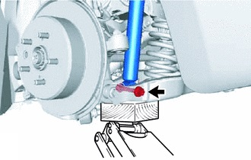
    - Remove the bolt and nut (Fig. 4-6). Retain them for reinstallation.
19mm socket& wrench and ratchet
Fig. 4-6
CAUTION: The nut has a locking feature. Remove the bolt and nut by turning the BOLT while the nut is held in place.
  - Disconnect the rear trailing link arm.
    - Compress the lower control arm up higher so the drive axle is as close to level as possible.
CAUTION: Be sure not to lift the vehicle off of the lift arm.

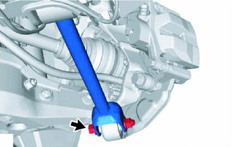
    - Remove the rearward bolt and nut from the trailing link arm (Fig. 4-7). Retain them for reinstallation.
17mm socket & wrench and ratchet
Fig. 4-7
CAUTION: The nut has a locking feature. Remove the bolt and nut by turning the BOLT while the nut is held in place.

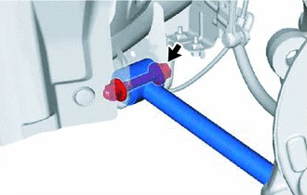
    - Loosen the forward bolt and nut on the trailing link arm until the arm swings down (Fig. 4-8). Do not remove the bolt or nut.
17mm socket & wrench and ratchet
Fig. 4-8

CAUTION: The nut has a locking feature. Loosen the bolt and nut by turning the BOLT while the nut is held in place.

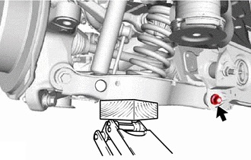
  - Loosen (do not remove) the rear lower control arm nut (rear suspension member sub-assembly side, Fig. 4-9).
19mm socket & wrench and ratchet
Fig. 4-9
CAUTION: Depending on the model vehicle, this fastener could be a nut or a bolt. Loosen the rearward facing fastener.

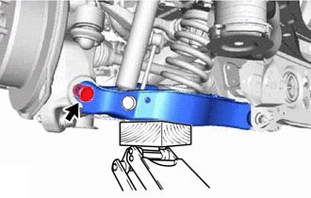
  - Remove the bolt and nut, and then separate the rear lower control arm from the rear knuckle assembly (Fig. 4-10).
19mm socket & wrench and ratchet
Fig. 4-10
CAUTION: The nut has a locking feature. Remove the bolt and nut by turning the BOLT while the nut is held in place.
  - Slowly lower the rear lower control arm just enough to free the lower end of the shock absorber from the lower control arm.
  - Repeat Step 4 on the other side of the vehicle.
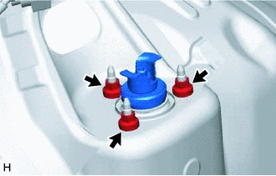
  - Remove the 3 nuts and then the rear shock absorber (Fig. 4-11).
14mm socket & ratchet
Fig. 4-11

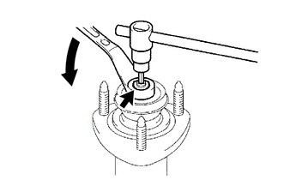
  - Remove the nut and the rear shock absorber upper support assembly (Fig. 4-12). Discard the nut as it will not be reused.
17mm socket, ratchet & 6mm hex wrench
Fig. 4-12
  - Install the supplied spacer back onto shock absorber shaft.

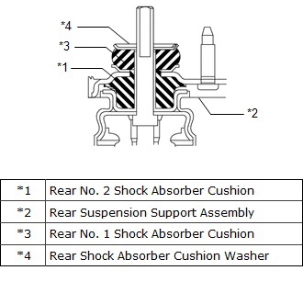
  - Install the rear No. 2 shock absorber cushion, rear suspension support assembly, rear No. 1 shock absorber cushion and rear shock absorber cushion washer to the rear shock absorber assembly (Fig. 4-13).
Fig. 4-13
CAUTION: Be sure to install the rear shock absorber cushion washer in the correct direction, with the lip turned up (*4 in Fig. 4-13).

  - Fully tighten the supplied nut (Fig. 4-14).
17mm socket, torque wrench & 6mm hex wrench
Fig. 4-14
CAUTION: Do not reuse the OE nut. The nut is intended for one-time use only.
Torque: 18 N·m (184 kgf·cm, 13 ft·lbf)

  - Install the shock absorber and reinstall the 3 nuts to the upper side of the rear shock absorber assembly (Fig. 4-15).
14mm socket & torque wrench
Fig. 4-15
Torque: 74 N·m (755 kgf·cm, 55 ft·lbf)

  - Replace the luggage compartment trim covers (Fig. 4-16).
10mm socket, ratchet
Fig. 4-16

Replace the Rear Shock Absorbers.
  - Slowly compress the rear lower control arm and then temporarily install the end of the shock absorber with the bolt and nut removed in Step 4(j)(3) (Fig. 5-1).
Fig. 5-1
CAUTION: Insert the bolt with the threaded end facing the front of the vehicle.

  - Slowly compress the rear lower control arm and then fasten it to the rear knuckle assembly with the bolt and nut removed in Step 4(m) (Fig. 5-2).
19mm socket & wrench and ratchet
Fig. 5-2
HINT: Use an awl to line up the holes to start the bolt. Use a socket with an extension on the bolt head to leverage the bolt through to the back side of the control arm.
CAUTION: The nut has a locking feature. Turn the BOLT while the nut is held in place.
  - Compress the lower control arm so that the drive axle is level.
CAUTION: Be sure not to lift the vehicle off of the lift arm.
  - Swing the trail link arm back into position and attach it to the knuckle with nut and bolt nut removed in Step 4(k)(2) (Fig. 5-3).
17mm socket & wrench and torque wrench
Fig. 5-3
CAUTION: The nut has a locking feature. Turn the BOLT while the nut is held in place.

  - Tighten both the forward and rearward trailing link bolts (Fig. 5-3 & Fig. 5-4).
17mm socket & wrench and torque wrench
Fig. 5-4
CAUTION: The nut has a locking feature. Turn the BOLT while the nut is held in place.
Torque: 90 N·m (918 kgf·cm, 66 ft·lbf)

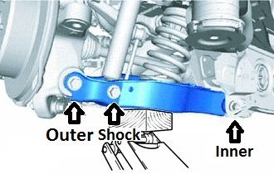
  - Tighten the inner lower control arm fastener (Fig. 5-5).
19mm socket & wrench and torque wrench
Fig. 5-5

CAUTION: Depending on the model vehicle, this fastener could be a nut or a bolt. Tighten the rearward facing fastener.
Torque: 150 N·m (1530 kgf·cm, 111 ft·lbf)
  - Tighten outer lower control arm bolt (Fig. 5-5).
CAUTION: The nut has a locking feature. Turn the BOLT while the nut is held in place.
Torque: 145 N·m (1479 kgf·cm, 107 ft·lbf)
  - Tighten the lower shock absorber bolt (Fig. 5-5).
CAUTION: The nut has a locking feature. Turn the BOLT while the nut is held in place.
Torque: 110 N·m (1122 kgf·cm, 81 ft·lbf)
  - Once the above steps have been completed for both sides of the vehicle, reattach the lower links of the sway bar with the nuts removed in Step 4(i) (Fig. 5-6).
17mm socket, torque wrench & 6mm hex wrench
Fig. 5-6
Torque: 70 N·m (714 kgf·cm, 52 ft·lbf)
  - Install the rear wheel/tire assemblies onto the vehicle. Hand start the lug nuts.

  - Use a torque wrench to tighten the lug nuts in sequence 1 through 5 to 103N∙m (76 ft-lbf) (Fig. 5-7).
2x

Fig. 5-7
Torque 2 Cycles
(All Lugs/Locks)
Torque: 103 N·m (1,050 kgf·cm, 76 ft·lbf)
  - Re-torque all of the lug nuts in same the 1-5 sequence (Fig. 5-7).
Torque: 103 N·m (1,050 kgf·cm, 76 ft·lbf)
CAUTION: DO NOT USE AN IMPACT WRENCH TO INSTALL OR REMOVE WHEEL LOCKS.

  - With the vehicle still on the lift, use a digital torque wrench to measure the torque of each lug nut/lock and record it on the Torque Audit Sheet (Fig. 5-8). (PPO installation only. Does not apply to DIO installation.)

Fig. 5-8
Measure Torque and Document
(All Lugs/Locks)

Adjust the Wheel Alignment.
  - Adjust the rear toe settings.
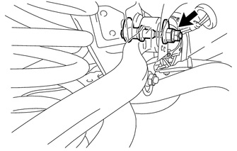
    - Loosen the inboard nut of the toe control link sub-assembly (Fig. 6-1).
19mm socket and ratchet
Fig. 6-1

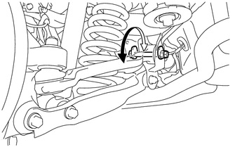
    - Rotate the rear suspension toe adjust cam sub-assembly to adjust the toe-in (Fig. 6-2).
24mm wrench
Fig. 6-2
HINT: Rotating the rear suspension toe adjust cam sub-assembly by one notch changes the toe by approximately 4.7 mm (0.185 in).
Total Toe:
0°11' +/- 0°11' (0.18° +/- 0.18°)
2.0 +/- 2.0 mm (0.0787 +/- 0.0787 in.)
    - Tighten the inboard nut of the toe control link sub-assembly (Fig. 6-1).
NOTE: Hold the rear suspension toe adjust cam sub-assembly while rotating the nut.
Torque: 117 N·m (1193 kgf·cm, 86 ft·lbf)
  - Adjust the front toe settings.
    - Confirm the steering wheel is locked in the straight ahead position.
    - Remove the outer steering rack boot clips from the boots.

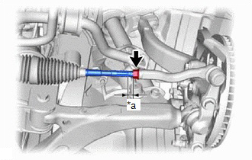
    - Loosen the tie rod lock nuts (Fig. 6-3).
19mm & 14mm wrenches
Fig. 6-3
    - Turn the right and left steering rack ends by an equal amount to adjust the toe-in.
Total Toe:
0°03' +/- 0°11' (0.05° +/- 0.18°)
0.5 +/- 2.0 mm (0.0197 +/- 0.0787 in.)
    - Make sure that the thread length of the right and left steering rack ends are the same (*a) (Fig. 6-3).
    - Tighten the tie rod lock nuts (Fig. 6-3).
Torque: 55.9 N·m (570 kgf·cm, 41 ft·lbf)
    - Replace the steering rack boots on the seats and install the steering rack boot clips.
NOTE:
- Make sure the steering rack boots are not twisted.
- Make sure the steering rack boot clips are facing towards the front of the vehicle.

Accessory Function Checks
Check for noise

Vehicle Function Checks
Confirm VSC light is not on
Confirm ASF OFF light is not on
Confirm all hardware with torque values are tight

Confirm all springs are seated properly

Speed sensor wires are plugged in
Height sensor links are positioned correctly
Loose hardware

Vehicle Appearance Check
After accessory installation and removal of protective cover(s), perform a visual inspection.

Ensure no damage (including scuffs and scratches) was caused during the installation process.
(For PPO installations, refer to TMS Accessory Quality Shipping Standard.)

